

**SECURITY ASSESSMENT**

<< **Udajuicer**>>

**Submitted to: Development Department, Udajuicer**

**Security Analyst: NAJD ALEID**

**Date of Testing: 25/10/2022**

**Date of Report Delivery: 26/10/2022**

# Table of Contents

|  |  |
| --- | --- |
| **Security Engagement Summary** | **2** |
| **Engagement Overview** | **2** |
| **Scope** | **2** |
| **Risk Analysis** | **3** |
| **Recommendation** | **4** |
| **Significant Vulnerability Summary** | **5** |
| **Medium Risk Vulnerabilities** | **5** |
| **Low Risk Vulnerabilities** | **7** |
| **Informational Risk Vulnerabilities** | **8** |
| **Significant Vulnerability Detail** | **7** |
| **10098 - Cross-Domain Misconfiguration** | **7** |
| **10017 - Cross-Domain JavaScript Source File Inclusion** | **8** |
| **10027 - Information Disclosure - Suspicious Comments** | **8** |
| **10096 - Timestamp Disclosure** | **8** |
| **CVE-2020-14145** | **8** |
| **CVE-2021-28041** | **8** |
| **CVE-2020-12062** | **9** |
| **CVE-2020-15778** | **9** |
| **Methodology** | **11** |
| **Assessment Tools Selection** | **11** |
| **Assessment Methodology Detail** | **12** |
| **Conclusion** | **14** |

**Security Engagement Summary**

## Engagement Overview

**The Development Team requested a vulnerability assessment of a legacy web-application.**

**The (Udajuicer) application was under attack, but the issue has been mitigated, the system was recovered and secured.**

**The goal of the engagement is to identify any potential areas of concern associated with the web application in its current state, provide solutions for reducing risks and fix vulnerabilities.**

**The engagement will be completed by the Information Security Department. All testing activities were performed on the staging environment provided by the customer and completely isolated from the production data.**

**- 1) Who requested the engagement and why?**

**The stakeholders are the people that requested the rules of Engagement.**

**In the set-up phase, Analysts are to meet with Stakeholders to discuss the scope and rule of Engagement.**

**The stakeholders are Business owners and management in an organization.**

**- 2) What are the engagement’s goals?**

**The goal of Engagement is to define how the assessment is to be executed.**

**Everything between the start to the end.**

**There is 7 steps in the rule of engagement:**

**1)Communication Plan 2) Meeting/Following Up Cadence**

**3) Emergency Contact 4) Report Deliverables 5) Scheduling 6) How to handle Evidence 7)Approvals/Permissions.**

**The Engagement’s goal is to analyze security weakness in an application.**

**Given that purpose of a web application vulnerability assessment is to take stock of your system’s overall security and**

**Identify any weaknesses. It is often recommended to conduct assessments, at least once a month to protect**

**Any existing and developing cyber threats.**

**- 3) Who is complete the engagement?**

**I believe it’s the Analyst’s job to complete the Engagement because the analyst should develop a plan**

**And the time it takes to execute the task . For Example) the analyst should develop a communication plan for**

**alerts or Status updates. An example of that is: At the end of workers every shift, they should provide status**

**updates to their supervisor.**

**- 4) How often is assessment completed?**

**>> The people that should assess your cyber security controls are people in the IT department.**

**You can choose people in IT department or take the recommended route of outsourcing cyber security audits to**

**Third party.**

**Assessments should be completed either monthly, quarterly, or bi-anually.**

**It is recommended that audits are performed at least twice a year.**

**Recurring Assessments like Cross Site Scripting(XSS) needs a frequency assessment, so that they can monitor and**

**prevent threats.**

**When they are performing assessments, they can do vulnerability assessment or penetration testing.**

**These methods can help make the security controls more secure because they can actively monitor for**

**Cyber threats.**

## Scope

**Vulnerability assessment can identify potential problems and weaknesses in an environment.**

**The web-application is highly accessible from the internet and hosts the company’s ecommerce solution. The website is used to handle customer requests.**

**This report summarizes what the Information Security Department believes are the most important issues to address in the application. The chart below outlines a number of issues identified, that are grouped by risk factors. Note the risk ratings were given to help assist in prioritizing remediation efforts.**

|  |  |
| --- | --- |
| **Risk Level** | **Description** |
| **High** | **These issues identity conditions that could directly result in the compromise or unauthorized access of a network, system, application or sensitive Information. Examples of High-Risk issues include remote execution of commands, known buffer overflows; unauthorized access and disclosure of sensitive information.** |
| **Medium** | **The issues identify conditions that do not immediately or directly result in the compromise or unauthorized access of a network, system, application or sensible information, but do provide a capability or information that could, in combination with other capabilities or information, result in the compromise or unauthorized access of a network, application or information.**  **Examples of Medium-Risk issues include directory browsing, partial access to files on the system, disclosure of security mechanisms and unauthorized use of services.** |
| **Low** | **These issues identify conditions that do not immediately or directly result in the compromise or unauthorized access of a network, system, application or sensitive information, but do provide information that could be used in combination with other information to gain insights into how to compromise or gain unauthorized access.to a network, system, application or information.** |
| **Informational** | **These issues, also known as information leakage, appear when a website unintentionally reveals sensitive information to its users.** |

**Identified issues by risk factor:**

|  |  |
| --- | --- |
| **Risk Level** | **Number of Alerts** |
| **High** | **0** |
| **Medium** | **1** |
| **Low** | **1** |
| **Informational** | **2** |

## Executive Risk Analysis

**Summarize the overall risk that the report indicates for the scope. ( High | Medium | Low )**

**The overall risk that the report indicates for the scope is High.**

**Explain why this risk level was reported. Include a summary of vulnerabilities in discussion (Executive Summary) form.**

**I would say that the risk level is high because part of the scope there is the valuation of identified resources.**

**Some of the Identified resources include : Game Server ,DLC Web sever.**

**In the Game Server, the risk level is high/ critical . In DLC Web Server, the risk level is high/critical.**

**Other servers : ERP Server, ERP DB Server, and LDAP Server.**

**ERP Server has high risk level. ERP DB Server has high/critical risk level .LDAP server has Medium/High.**

**I would say that the overall risk that the report indicates for the scope is High .**

**The website shows medium and low risk vulnerabilities. The web-application shows misconfiguration which could be used by an attacker to access data that is available in an unauthenticated manner.**

|  |  |  |
| --- | --- | --- |
| **Name** | **Risk Level** | **Number of Instances** |
| **Cross-Domain Misconfiguration** | **Medium** | **30** |
| **Cross-Domain JavaScript Source File Inclusion** | **Low** | **6** |
| **Information Disclosure - Suspicious Comments** | **Informational** | **6** |
| **Timestamp Disclosure - Unix** | **Informational** | **23** |

**Exploration of these flaws is inevitable. An attack can have a severe impact on the business. The Information Security Department strongly recommends to remediate all issues detected to mitigate against the possible risk of a sensitive data compromise.**

## Executive Recommendation

* **Issue a maintenance window to perform the necessary fixes.**
* **Send a message informing customer of the downtime.**
* **Create backups to restore the system in case of failure.**
* **Conduct follow-up scanning**

**In discussion (Executive Summary) form, explain if remediation efforts are warranted. Describe at a high level how to**

**best mitigate or remediate the highest-risk vulnerabilities Prioritize which vulnerability should be remediated first and why.**

**1 ) Yes, I would say that remediation efforts are warranted because remediation is part of the**

**Vulnerability Assessment stage. If remediation is a part of the process, then it will make it more safe.**

**The best way to mitigate or remediate high-risk vulnerabilities is :**

**1) Risk Acceptance 2) Risk Reduction**

**3) Risk Transfer 4) Risk Avoidance.**

**The first strategy is Risk Acceptance, and in this strategy you can just accept the risk and do nothing.**

**The second strategy is Risk Reduction, in where you take measures to reduce the risk so that it can be at an acceptable**

**level.**

**The third strategy is Risk Transfer. In this step, you transfer the risk to another person.**

**The third strategy is Risk Avoidance. In this step, you try to avoid risk.**

**You should prioritize vulnerability base on its risk level, so I would rank the risk and the higher the risk than the more**

**attention you should focus on the risk. The vulnerability would be: critical, high, medium, low.**

**I would focus my attention on critical as the most important because it’s the most dangerous, then I would consider high**

**as my next urgent risk. Medium is third on that list, and I would consider low as the lowest priority.**

# Significant Vulnerability Summary

Provide a list of the highlighted vulnerabilities in descending order of assessed risk High | Medium | Low

### **High Risk Vulnerabilities**

* **CVE-2021-3154( 7.5 Base Score : High)**

### **Medium Risk Vulnerabilities**

* **CVE -2021-3524 (6.5 Base Score: Medium )**

### **Low Risk Vulnerabilities**

* **CVE-2020-16092 ( 3.8 Base Score : Low)**

**During the course of this assessment, the Information Security Department did not identify any critical vulnerabilities that could lead to full compromise of the system. However, several medium and low severity issues were found, which should be addressed promptly.**

**Medium Risk Vulnerability: 10098 - Cross-Domain Misconfiguration (Page 6/7)**

**Low Risk Vulnerability: 10017 - Cross-Domain JavaScript Source File Inclusion (Page 8) Information Risk Vulnerability: 10027 - Information Disclosure - Suspicious Comments (Page 9) Information Risk Vulnerability: 10096 - Timestamp Disclosure (Page 9)**

**AC** CVE-2020-14145* 4.3** [**https://vulners.com/cve/CVE-2020-14145**](https://vulners.com/cve/CVE-2020-14145) **(Page 9)**

**AC** CVE-2021-28041* 4.6** [**https://vulners.com/cve/CVE-2021-28041**](https://vulners.com/cve/CVE-2021-28041) **(Page 9)**

**AC** CVE-2020-12062* 5.0** [**https://vulners.com/cve/CVE-2020-12062**](https://vulners.com/cve/CVE-2020-12062) **(Page 10)**

**AC** CVE-2020-15778* 6.8** [**https://vulners.com/cve/CVE-2020-15778**](https://vulners.com/cve/CVE-2020-15778) **(Page 10)**

**\*CVE stands for** [**Common Vulnerabilities and Exposures**](https://en.wikipedia.org/wiki/Common_Vulnerabilities_and_Exposures)**. The Common Vulnerabilities and Exposures (CVE) system provides a reference-method for publicly known** [**information-security**](https://en.wikipedia.org/wiki/Information_security) [**vulnerabilities**](https://en.wikipedia.org/wiki/Vulnerability_(computing)) **and exposures. The** [**National Cybersecurity FFRDC**](https://en.wikipedia.org/wiki/National_Cybersecurity_FFRDC)**, operated by** [**The MITRE Corporation**](https://en.wikipedia.org/wiki/The_MITRE_Corporation)**, maintains the system, with funding from the** [**National Cyber Security Division**](https://en.wikipedia.org/wiki/National_Cyber_Security_Division) **of the United States Department of Homeland Security.**

**\*\*AC = Access Complexity**

# Significant Vulnerability Detail

## Vulnerability Name

#### **RISK LEVEL HIGH | MEDIUM | LOW**

**Vulnerability detail**

* **Provide the assessed risk level (High | Medium | Low ) of the vulnerability.**
* **Discussion (Executive Summary) form, explain how the vulnerability was identified and validated.**
* **Provide evidence of validation (Screenshot, log excerpt, etc.)**
* **Discuss the probability of exploit/attack.**
* **Discuss who would be impacted if the attack was exploited (users-groups, departments, business- continuity/revenue)**
* **Discuss potential remediation**

**1) The first Vulnerability that I analyzed was CVE-2021-3154 .**

**The risk level is High because the Base Score : 7.5 is considered high risk .**

* 1. **The vulnerability was identified by I went to the cve.mitre.org . I went on that website, so that I can analyze vulnerability because on that website it gives you the vulnerability and it also gives you the risk score. It will tell you if the vulnerability is: critical, high , medium, or low**

**The vulnerability was identified because I went on the website I mentioned above, and it was validated by I saw the risk score next to the vulnerability**

* 1. **Screenshot.**

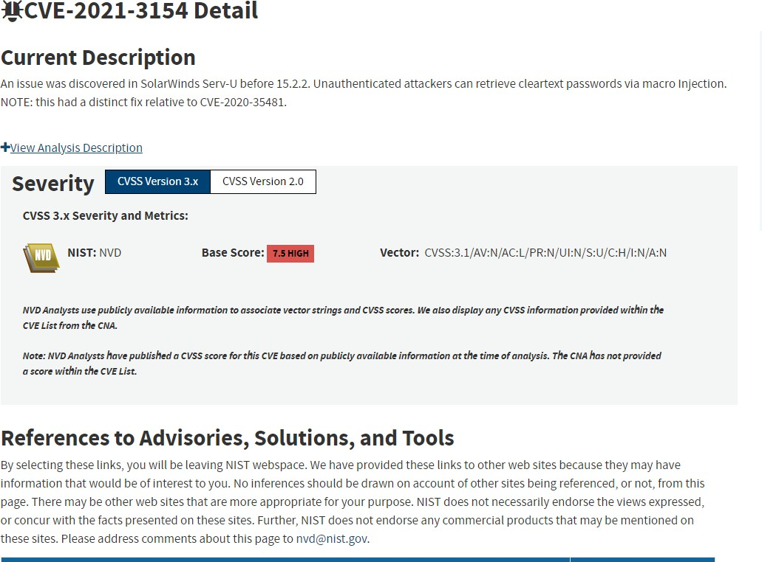

* 1. **The CVE-2021-3154 Vulnerability is a vulnerability where Unauthenticated attackers can retrieve cleartext passwords via macro Injection. The probability would be high risk because cleartext passwords are stolen.**
  2. **If the attack was exploited, I believe that it would affect businesses because if cleartext passwords are stolen, then unauthorized users can gain access, and it would give permission to unauthorized users.**
  3. **The potential remediation is that they should install applications that encrypt cleartext passwords, so that it would be hard to decipher.**

## Vulnerability Name

#### **RISK LEVEL HIGH | MEDIUM | LOW**

**Vulnerability detail**

* **Provide the assessed risk level (High | Medium | Low ) of the vulnerability.**
* **Discussion (Executive Summary) form, explain how the vulnerability was identified and validated.**
* **Provide evidence of validation (Screenshot, log excerpt, etc.)**
* **Discuss the probability of exploit/attack.**
* **Discuss who would be impacted if the attack was exploited (users-groups, departments, business- continuity/revenue)**
* **Discuss potential remediation**

**1. For the CVE -2021-3524 vulnerability, it is a vulnerability that has medium risk. It is medium risk because the base score is 6.5, and that is considered medium risk.**

1. **The vulnerability was identified by I went to the website cve.mitre.org , so that I can analyze the vulnerabilities.**

**It was validated by I went on the website, and I chose CVE-2021-3524 vulnerability, and next to it there is a Base Score:**

**6.5 and 6.5 is considered to be medium risk.**

* + 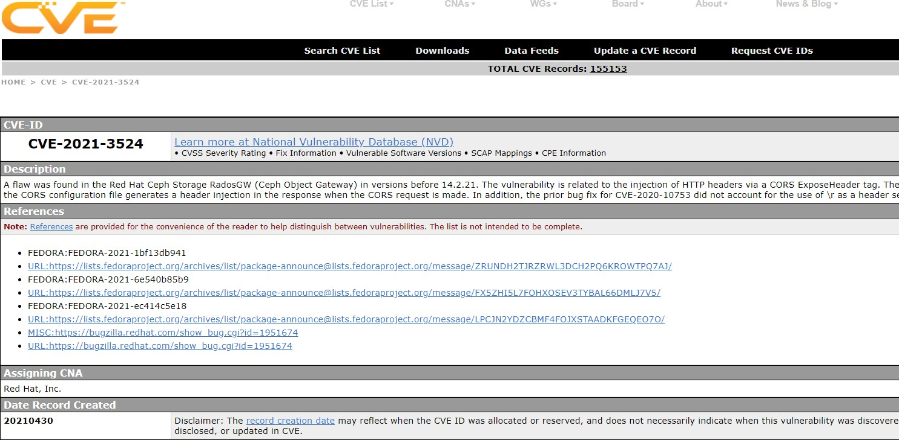**Screenshot below.**

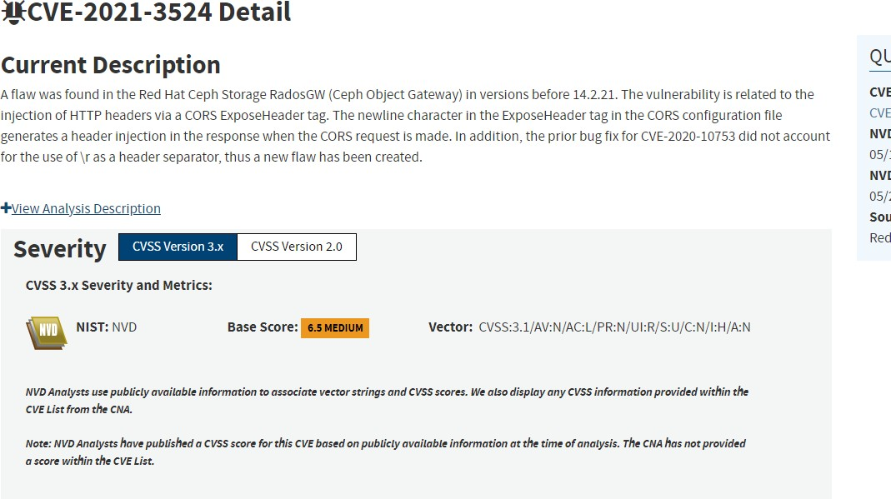

* + 1. **The CVE-2021-3524 vulnerability is a vulnerability is related to injections of HTTP headers. I would say that it is dangerous risk, and it should be prevented if possible.**

**I believe the probability of exploit is medium.**

* + 1. **I would say that the people that would be affected is departments.**

**Since this attack affects HTTP Headers, I believe it will affect Programmers/Software Engineer Department and IT Department.**

* + 1. **The possible remediation is that they should install a software application that constantly monitors the computer for threats.**

## Vulnerability Name

#### **RISK LEVEL HIGH | MEDIUM | LOW**

**Vulnerability detail**

* **Provide the assessed risk level (High | Medium | Low ) of the vulnerability.**
* **Discussion (Executive Summary) form, explain how the vulnerability was identified and validated.**
* **Provide evidence of validation (Screenshot, log excerpt, etc.)**
* **Discuss the probability of exploit/attack.**
* **Discuss who would be impacted if the attack was exploited (users-groups, departments, business- continuity/revenue)**
* **Discuss potential remediation**

**1) For the CVE-2020-16092 vulnerability, the risk level is low risk.**

**It is low risk because the base score : 3.8 , and it is considered low risk.**

1. **The vulnerability was identified by I went to the website cve.mitre.org ,and I was browsing for vulnerabilities. I chose CVE-2020-16092 vulnerability, then I analyzed the vulnerability.**
2. **Screenshot. On the next page.**

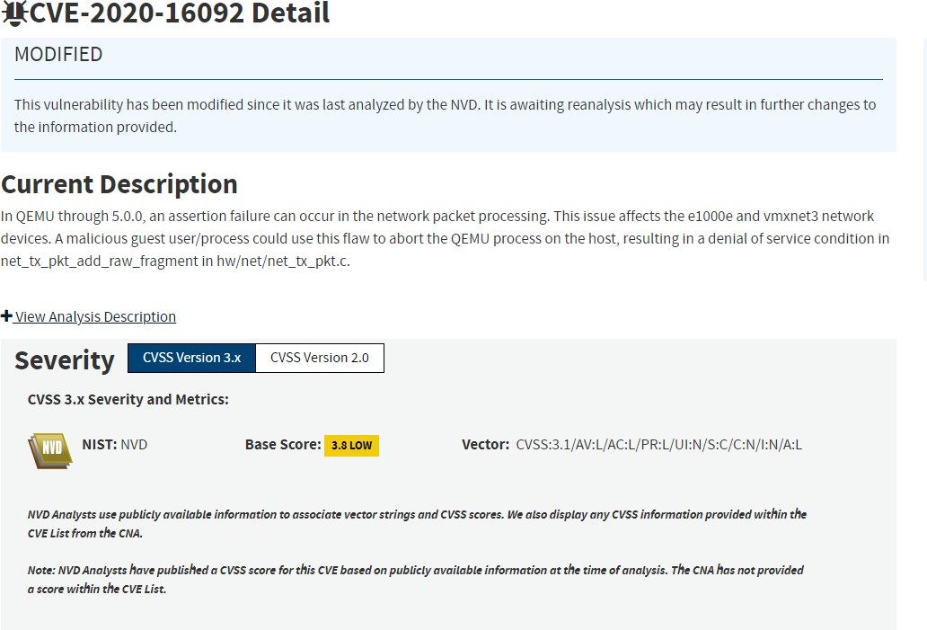

1. **The probability of the attack is low because it is low risk.**
2. **For the CVE-2020-16092 vulnerability, it is a vulnerability where a malicious guest can use a flaw that can abort the QEMU on the host, that can result in Denial of Service(DOS) Condition.**

**I would say that the people that would be affected would be business and departments.**

**The Denial of Service(DOS) attack can affect business by the unauthorized users can flood the network, and cause the company’s network to crash resulting in where employees of company can be without work because it will take time to fix the nextwork.**

**It would affect the IT department because if an unauthorized users uses DOS attack, it can cause the IT personnel to immediately remediate the Dos attack.**

**6.) The potential remediation is that you can build a firewall, so that the firewall can mitigate potential threats. The Firewall is a good mitigation strategy against Dos attacks because it can filter incoming/outgoing traffic.**

|  |
| --- |
| **Medium Risk Vulnerability: 10098 - Cross-Domain Misconfiguration** |
| **Description: Web browser data loading may be possible, due to a Cross Origin Resource Sharing (CORS) misconfiguration on the web server** |
| **Information: The CORS misconfiguration on the web server permits cross-domain read requests from arbitrary third party domains, using unauthenticated APIs on this domain. Web browser implementations do not permit arbitrary third parties to read the response from authenticated APIs, however. This reduces the risk somewhat. This misconfiguration could be used by an attacker to access data that is available in an unauthenticated manner, but which uses some other form of security, such as IP address white-listing.** |
| **Solution: Ensure that sensitive data is not available in an unauthenticated manner (using IP address white-listing, for instance).**  **Configure the "Access-Control-Allow-Origin" HTTP header to a more restrictive set of domains, or remove all CORS headers entirely, to allow the web browser to enforce the Same Origin Policy (SOP) in a more restrictive manner.** |
| **Reference:** [**http://www.hpenterprisesecurity.com/vulncat/en/vulncat/vb/html5_overly_permissive_cors_policy.ht**](http://www.hpenterprisesecurity.com/vulncat/en/vulncat/vb/html5_overly_permissive_cors_policy.ht) **ml** |
| **Code:**  **<!--**  **~ Copyright (c) 2014-2020 Bjoern Kimminich.**  **~ SPDX-License-Identifier: MIT**  **-->**  **<!doctype html>**  **<html lang="en">**  **<head>**  **<meta charset="utf-8">**  **<title>OWASP Juice Shop</title>**  **<meta name="description" content="Probably the most modern and sophisticated insecure web application">**  **<meta name="viewport" content="width=device-width, initial-scale=1">**  **<link id="favicon" rel="icon" type="image/x-icon" href="assets/public/favicon_js.ico">**  **<link rel="stylesheet" type="text/css" href="//cdnjs.cloudflare.com/ajax/libs/cookieconsent2/3.1.0/cookieconsent.min.css" />**  **<script src="//cdnjs.cloudflare.com/ajax/libs/cookieconsent2/3.1.0/cookieconsent.min.js"></script>**  **<script src="//cdnjs.cloudflare.com/ajax/libs/jquery/2.2.4/jquery.min.js"></script>**  **<script>**  **window.addEventListener("load", function(){** |

|  |
| --- |
| **window.cookieconsent.initialise({**  **"palette": {**  **"popup": { "background": "#546e7a", "text": "#ffffff" },**  **"button": { "background": "#558b2f", "text": "#ffffff" }**  **},**  **"theme": "classic",**  **"position": "bottom-right",**  **"content": { "message": "This website uses fruit cookies to ensure you get the juiciest tracking experience.", "dismiss": "Me want it!", "link": "But me wait!", "href": "https:/**[**/www.yo**](http://www.youtube.com/watch?v=9PnbKL3wuH4)**u**[**tube.com/watch?v=9PnbKL3wuH4**](http://www.youtube.com/watch?v=9PnbKL3wuH4)**" }**  **})});**  **</script>**  **<link rel="stylesheet" href="styles.css"></head>**  **<body class="mat-app-background bluegrey-lightgreen-theme">**  **<app-root></app-root>**  **<script src="runtime-es2015.js" type="module"></script><script src="runtime-es5.js" nomodule defer></script><script src="polyfills-es5.js" nomodule defer></script><script src="polyfills- es2015.js" type="module"></script><script src="vendor-es2015.js" type="module"></script><script src="vendor-es5.js" nomodule defer></script><script src="main-es2015.js" type="module"></script><script src="main-es5.js" nomodule defer></script></body>**  **</html>** |

|  |
| --- |
| **Low Risk Vulnerability: Passive 10017 - Cross-Domain JavaScript Source File Inclusion** |
| **Description: The page includes one or more script files from a third-party domain.** |
| **Solution: Ensure JavaScript source files are loaded from only trusted sources, and the sources can't be controlled by end users of the application.** |
| **<!--**  **~ Copyright (c) 2014-2020 Bjoern Kimminich.**  **~ SPDX-License-Identifier: MIT**  **-->**  **<!doctype html>**  **<html lang="en">**  **<head>**  **<meta charset="utf-8">**  **<title>OWASP Juice Shop</title>**  **<meta name="description" content="Probably the most modern and sophisticated insecure web application">**  **<meta name="viewport" content="width=device-width, initial-scale=1">**  **<link id="favicon" rel="icon" type="image/x-icon" href="assets/public/favicon_js.ico">**  **<link rel="stylesheet" type="text/css" href="//cdnjs.cloudflare.com/ajax/libs/cookieconsent2/3.1.0/cookieconsent.min.css" />**  **<script src="//cdnjs.cloudflare.com/ajax/libs/cookieconsent2/3.1.0/cookieconsent.min.js"></script>**  **<script src="//cdnjs.cloudflare.com/ajax/libs/jquery/2.2.4/jquery.min.js"></script>**  **<script>**  **window.addEventListener("load", function(){**  **window.cookieconsent.initialise({**  **"palette": {**  **"popup": { "background": "#546e7a", "text": "#ffffff" },**  **"button": { "background": "#558b2f", "text": "#ffffff" }**  **},**  **"theme": "classic",**  **"position": "bottom-right",**  **"content": { "message": "This website uses fruit cookies to ensure you get the juiciest tracking experience.", "dismiss": "Me want it!", "link": "But me wait!", "href": "https:/**[**/www.yo**](http://www.youtube.com/watch?v=9PnbKL3wuH4)**u**[**tube.com/watch?v=9PnbKL3wuH4**](http://www.youtube.com/watch?v=9PnbKL3wuH4)**" }**  **})});**  **</script>**  **<link rel="stylesheet" href="styles.css"></head>**  **<body class="mat-app-background bluegrey-lightgreen-theme">**  **<app-root></app-root>**  **<script src="runtime-es2015.js" type="module"></script><script src="runtime-es5.js" nomodule defer></script><script src="polyfills-es5.js" nomodule defer></script><script src="polyfills- es2015.js" type="module"></script><script src="vendor-es2015.js" type="module"></script><script src="vendor-es5.js" nomodule defer></script><script src="main-es2015.js" type="module"></script><script src="main-es5.js" nomodule defer></script></body>**  **</html>** |

|  |
| --- |
| **Information Risk Vulnerability: Passive 10027 - Information Disclosure - Suspicious Comments** |
| **Description: The response appears to contain suspicious comments which may help an attacker. Note: Matches made within script blocks or files are against the entire content not only comments.** |
| **Solution: Remove all comments that return information that may help an attacker and fix any underlying problems they refer to.** |
| **URL: http://192.168.0.20:3000/polyfills-es5.js** |

|  |
| --- |
| **Information Risk Vulnerability: Passive 10096 - Timestamp Disclosure** |
| **Description: A timestamp was disclosed by the application/web server - Unix** |
| **Information: 33333333, which evaluates to: 1971-01-21 14:15:33** |
| **Solution: Manually confirm that the timestamp data is not sensitive, and that the data cannot be aggregated to disclose exploitable patterns.** |
| **Reference:** [**http://projects.webappsec.org/w/page/13246936/Information%20Leakage**](http://projects.webappsec.org/w/page/13246936/Information%20Leakage) |
| **URL: http://192.168.0.20:3000/styles.css** |

**Vulnerabilities discovered with NMAP-Vulners / port 22:**

|  |
| --- |
| **Description:** [**Common Vulnerabilities and Exposures**](https://en.wikipedia.org/wiki/Common_Vulnerabilities_and_Exposures) |
| **ID: CVE-2020-14145** |
| **Information: The client side in OpenSSH 5.7 through 8.4 has an Observable Discrepancy leading to an information leak in the algorithm negotiation. This allows man-in-the-middle attackers to target initial connection attempts (where no host key for the server has been cached by the client).** |

|  |
| --- |
| **Description:** [**Common Vulnerabilities and Exposures**](https://en.wikipedia.org/wiki/Common_Vulnerabilities_and_Exposures) |
| **ID: CVE-2021-28041** |
| **Information: ssh-agent in OpenSSH before 8.5 has a double free that may be relevant in a few less-common scenarios, such as unconstrained agent-socket access on a legacy operating system, or the forwarding of an agent to an attacker-controlled host.** |

|  |
| --- |
| **Description:** [**Common Vulnerabilities and Exposures**](https://en.wikipedia.org/wiki/Common_Vulnerabilities_and_Exposures) |
| **ID: CVE-2020-12062** |
| **Information: DISPUTED The scp client in OpenSSH 8.2 incorrectly sends duplicate responses to the server upon a utimes system call failure, which allows a malicious unprivileged user on the remote server to overwrite arbitrary files in the client’s download directory by creating a crafted subdirectory anywhere on the remote server. The victim must use the command scp -rp to download a file hierarchy containing, anywhere inside, this crafted subdirectory. NOTE: the vendor points out that “this attack can achieve no more than a hostile peer is already able to achieve within the scp protocol” and “utimes does not fail under normal circumstances.”** |

|  |
| --- |
| **Description:** [**Common Vulnerabilities and Exposures**](https://en.wikipedia.org/wiki/Common_Vulnerabilities_and_Exposures) |
| **ID: CVE-2020-15778** |
| **Information: DISPUTED scp in OpenSSH through 8.3p1 allows command injection in the scp.c to remote function, as demonstrated by backtick characters in the destination argument. NOTE: the vendor reportedly has stated that they intentionally omit validation of “anomalous argument transfers” because that could “stand a great chance of breaking existing workflows.”** |

# Methodology

**The Information Security Department based the findings and recommendations, outlined in this report, on application vulnerability scans performed against the application.**

## Assessment Tools Selection

**OWASP ZAP is an open-source web application security scanner.**

**Nmap ("Network Mapper") is a free and open source (**[**license**](https://nmap.org/npsl/)**) utility for network discovery and security auditing.**

**Vulners is an Nmap NSE script, using some well-known services to provide info on vulnerabilities.**

## Assessment Methodology Detail

**OWASP ZAP Automated Application Scan**

**The Information Security Department used several Open-Source tools to survey the targeted environment and identify potential vulnerabilities. The automated scanning software identifies application-level vulnerabilities.**

**The scope of testing with OWASP ZAP includes the following:**

* **SQL Injection**
* **Path Traversal**
* **Remote File Inclusion**
* **Source Code Disclosure**
* **External Redirect**
* **Server Side Include (Reflected)**
* **Cross Site Scripting (Persistent) - Prime**
* **Cross Site Scripting (Persistent) - Spider**
* **Cross Site Scripting (Persistent)**
* **Server-Side Code Injection**
* **Remote OS Command Injection**
* **Directory Browsing**
* **Buffer Overflow**
* **Format String Overflow**
* **CRLF Injection**
* **Parameter Tampering**
* **ELMAH Information Leak**
* **.htaccess Information Leak**
* **Script Active Scan Rules**
* **Cross Site Scripting (DOM Based)**
* **SOAP-Action Spoofing**
* **SOAP-XML Injection**

**The screenshots below show set up and vulnerability scan results in OWASP Zap:**

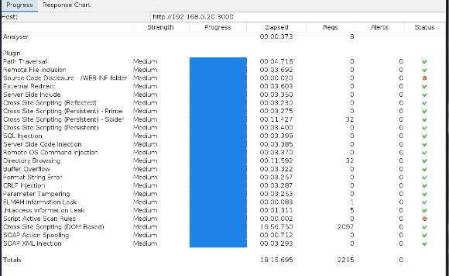

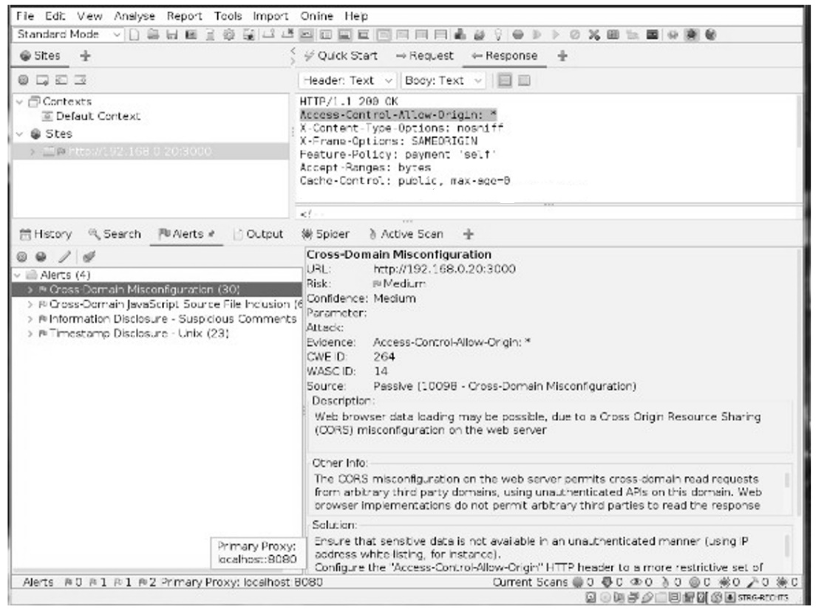

**Nmap Vulners NSE script**

**Nmap-vulners queries the** [**Vulners**](https://vulners.com/docs) **exploit database every time we use the NSE script.**

**nmap 192.168.0.20 -sV --script=vulners (-p 3000) Output:**

**- - -**

**PORT STATE SERVICE VERSION**

**22/tcp open ssh OpenSSH 8.2p1 Ubuntu 4 ubuntu0.2 (Ubuntu Linux; protocol 2.0)**

**| vulners:**

**| cpe:/a:openbsd:openssh:8.2p1:**

**| CVE-2020-15778 6.8 https://vulners.com/cve/CVE-2020-15778**

**| CVE-2020-12062 5.0 https://vulners.com/cve/CVE-2020-12062**

**| CVE-2021-28041 4.6 https://vulners.com/cve/CVE-2021-28041**

**| CVE-2020-14145 4.3 https://vulners.com/cve/CVE-2020-14145**

**- - -**

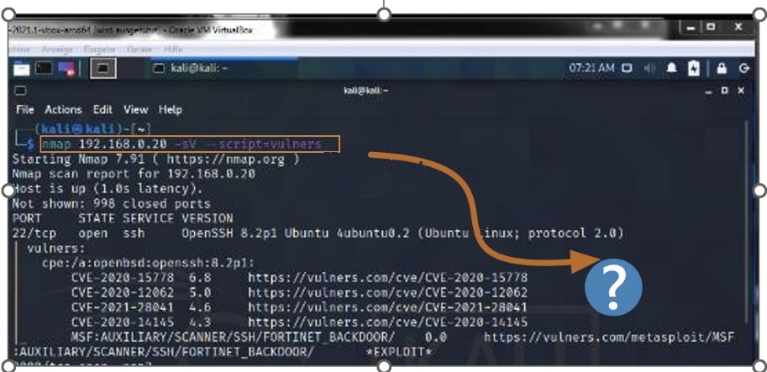

**All vulnerabilities have related references, definitions and severity which complete full information of any known bulletins. Visit** [**https://vulners.com/**](https://vulners.com/) **for detailed information.**

## Conclusion

**The Information Security Department completed the vulnerability testing of the web application. This testing was based on the technologies and known threats as of the date of this document. All the security issues discovered during that exercise were analyzed and described in this report.**

**Please note that as technologies and risks change over time, the vulnerabilities associated with the operation of systems described in this report, as well as the actions necessary to reduce the exposure to such vulnerabilities, will also change.**